Writing for Understanding and Common Core
Teacher Plan

Teacher Ingrid M. Johnson Grade Pre-K and K Time Writing 5 days (part of unit)

Topic / Subject / Text
Weather/science/ When the Wind Bears Go Dancing, by Phoebe Stone
and other texts

CENTRAL IDEAS

Content: Wind is a kind of weather and it changes it’s force. (Science concept about weather and changes.)

Reading CC Standards:
(RL.K.3) With prompting and support, identify characters, settings, and major events in a story.
(RL.K.4) Ask and answer questions about unknown words in a text.
(RL.K.7) With prompting and support, describe the relationship between illustrations and the story in which they appear(e.g. what moment in a story an illustration depicts).
(R.I.K.10)Actively engage in group reading activities with purpose and understanding.
(RF.K.2a)Recognize and produce rhyming words.

Writing CC Standards:
(W.K.1) Use a combination of drawing, dictating, and writing to compose opinion pieces in which they tell a reader the topic or the name of the book they are writing about and state an opinion or preference about the topic or book(e.g. My favorite book is…)

Other CC Standards:
(L.K.4) Determine or clarify the meaning of unknown and multiple-meaning words and phrases based on kindergarten reading and content.

Focusing Question | Focus (answer to focusing question)
What does the wind do in this story?  Aternate:  How does the wind behave in this story? | The wind can behave in many ways. It can be very gentle and grow very strong. When the wind blows like a dancing bear nothing sits still.

Test Drive
When the Wind Bears Go Dancing By Phoebe Stone
The wind can behave in many ways. It can be very gentle and grow very strong. When the wind blows like a dancing bear nothing sits still. (This much is the promt.)
The wind can bang shutters and doors. It can make the roof bump in a storm. It roars and rumbles like a bear.
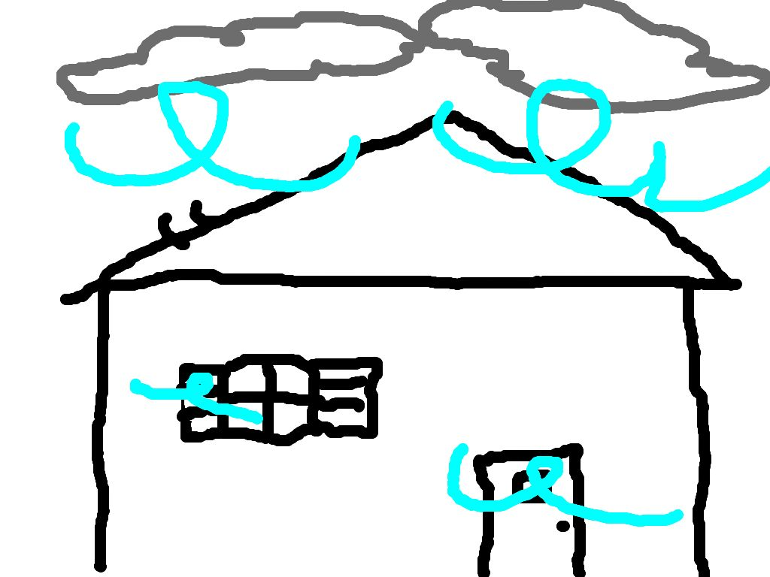
The child would be able to place his/her piece on the classroom chart designated for strong wind examples to demonstrat he/she understood the force of the wind they represented.

Building Content Knowledge, Understanding of Writer’s Craft

• vocabulary  • close reading  • text mapping  • paraphrasing  • summarizing  • visualizing/  • imaging  • dramatizing  • oral processing / guided  conversation / think-pair-  share  • experience  • debating / Socratic seminar  • taking notes (graphic  organizers, T-charts, 2 column  notes, etc.)  • craft lessons (intro, transitions, conclusions, etc) | Many books both literature and informational, photos, video clips, Smartboard resourses,a fan, and outdoor explores about wind and other weather all involving a variety of types of oral processing.  Bulletin board display of examples of weather  Sorting Activity: Using a collection of stuffed animals, photo or illustrations, and models to sort into hoops for attributes of force. A hoop for each set of attributes- gentle/mild/easy-going animals, strong/powerful/fierce animals, and in-between animals  Smartboard sorting activity-pictures with words into T chart force of weather and graphic organizer to practice understanding of types of weather  Use the fan to explore force-gentle to strong  Songs, finger-plays, nursery rhymes, music selections about weather  Daily calendar recording on a graph of weather of the day and dress weather bear appropriately  Close read to find the ideas the teacher model used using Elmo  Vocabulary will be taught- charts will be created for public notes and props will be availlable for student use. The teacher will guide  oral repetitions of words, help students create visual representations (drawings or cut and paste pictures),and help students explore movements to pantomime words, musical instruments to demonstrate sound words(e.g. drum to rumble, or rainstick/maraca to imitate rain) blizzard windless calm  roam rumble howling yowling bassoon swoon chorus refrain  wild frisky shiver lash splatter flash thunderclap rattle-bang  romp eaves zigzags zepher breeze frigid extreme stratus  cumulus nimbus gust breeze gale tornado hurricane typhoon  Razzle dazzle- use a sparkly crown and cane with dance moves  Multiple oral reads of anchor text:  Teacher will read the book as a listening only activity to allow the words to build an image in the students’ minds.  Visualize and Verbalize Activity-tell us what can you “see” (children explain the image in their minds-eye and ask each other for clarification)  Teacher will read text orally in short chunks for different purposes. For example-ask the students to listen for certain words or sounds at the beginning and jump up when you hear rattle-bang or sound of  /w/,etc.  Teacher and students will create a sound words list as public notes on chart  Picture Walk- illustrations are closely observed and discussed with illustrator’s purposes in mind  Review teacher model and create a teacher-and-student model  Review the anchor chart of focus question and focus statement.

Structures

How will students know how to organize their ideas
and construct the piece of writing?

• graphic organizers  • teacher-written models  • teacher-and-student  written models  • various types of templates  or frames  (ex: Painted Essay) | -T chart of examples of wind force  -graphic organizer on Smartboard for sorting types of weather  -Teacher written model  -teacher and student model created together  -frame providing the focus statement  -orally written piece modeled by the children-the children “test drive” their ideas in the class matching their words to the focus question and what they would like to illustrate with their drawing (this should help avoid errors)

Writing / Revising

How will students draft / revise so that their final writing is clearly focused,
organized, and developed to show understanding of the central ideas?

• group write, fully or in  part  • write section at a time  • write full piece  independently  • revise /share full group  • revise /share partners  • proofreading in partners  • proofread w/tubaloos | -group write fully to create as a model for public notes  -children will orally “write aloud’ as a practice “test drive” in a group share  -children will draw their idea then dictate their ideas and/or write  -revise/share in full group(small class size affords this) or small group

Lesson Sequence
What steps will I follow so that students are able to effectively
show their understanding in writing?
For several weeks prior to writing task to build understanding:
Daily review the weather and graph it to practice types of weather identification-note the count of each and decide most/fewest/equal
Daily dress the weather bear to demonstrate appropriate clothing for the weather.
Physically sort ourselves based on clothing-e.g. sleeveless or short sleeves and count each group to find which has more/less/equal.
At morning meeting teach these nursery rhymes by echo: “It’s Raining It’s Pouring,” “Rain, Rain Go Away,” “ One Misty, Moisty Monring,’ “Mistress Mary, Quite Contrary,” and “Buttercups and Daisies.” Group recite nursery rhymes and find the rhyming words to prepare students for finding rhyme in other texts. Sing, dance, do finger-plays, and share poems listed on resource page.
At morning recess check the force of the wind and record on chart in classroom (outdoor explore) and check the towel outside readily visible from classroom to also check force of wind-this will be used as a graphic to illustrate new vocabulary words of force. We can also practice using the fan to create force of wind to use appropriate vocabulary (indoor explore),

Immediately prior to starting this unit arrange many books both literature and informational about wind and other weather in the student book display rack and place photos and key vocabulary up on the bulletin board in a display of examples of weather with unit words. The children will have access to these resources throughout the unit.

Read a variety of informational texts about types of weather:
Big Book of Science Songs and Rhymes, Harcourt School Publishers
Big Book of Science Readers, Harcourt School Publishers
Who Cares About the Weather?, by Melvin Berger
Rain, by Gail Saunders-Smith
Lightning, by Gail Saunders-Smith
Clouds, by Gail Saunders-Smith
Sunshine, by Gail Saunders-Smith

After reading each of these informational texts, vocabulary will be added to the bulletin board. Charts will be created on chart paper or pages on the Smartboard to list important information.

Read literature with weather themes-teach character, setting, main events:
(Big Books)
It Looks Like Spilled Milk, by Charles G. Shaw
The Itsy Bitsy Spider, by
Two Feet, by Gwen Pascoe and David Kennett
The Wind Blew, by Pat Hutchins
Caps, Hats, Socks, and Mittens, A Book About the Four Seasons, by Louis Borden and illustrated by Lillian Hoban
I Love You, Sun I Love You, Moon, by Karen Pandell and illustrated by
Tomie dePaola
Peter and the North Wind, retold by Freya Littledale and illustrated by Troy Howell (Assessment Checklist)
The Rainbabies, by Laura Krauss Melmed and illustrated by Jim LaMarche (Assessment Checklist)
The Sun is My Favorite Star, by Frank Ashe
How the Rabbit Caught the Tiger, A Korean Folk Tale, retold by Anne O’Brien (5 )
The Snow Game, by Patricia Griffith (5 copies)
Teach simile-e.g. grouchy as a bear, mean as a rattlesnake, hungry as a lion, fierce as a tiger with a sore paw, alert as a mouse at full moon
Teach metaphor-e.g. my cloud bed
Use the variety of texts to teach vocabulary words and phrases.
(The activities and lessons will be modified based on observations of children’s demonstration of understanding of vocabulary and concepts related to this unit. Instruction will be whole group at times and/or small group based on observed needs of the children.)

Close read process for When the Wind Bears Go Dancing, by Phoebe Stone
Day One For the Anchor Text: The focus question will be posted and read aloud to the class. Then the
teacher will read the book while children close their eyes and just listen to the words of When the Wind Bears Go Dancing, by Phoebe Stone. The children will be asked to visualize what they are hearing and be prepared to verbalize. This will allow children to orally process what they experienced and hear what other children experienced. Then teacher will reread the first few sets of pages slowly. The children will be asked to listen carefully and be ready to retell what is happening on those pages. Who is in the story? Where is the story happening? This will help all the children be able to comprehend the story more fully. The children will be asked to listen for sound words. Teacher will guide and record the information on a chart. No illustrations will be seen today. We will find the rhymes in this first section by oral processing.
Sorting Activity: Using a collection of stuffed animals, photo or illustrations, and models to sort into hoops for attributes of force. A hoop for each set of attributes- gentle/mild/easy-going animals, strong/powerful/fierce animals, and in-between animals

Day Two For the Anchor Text:
Teacher will read more of the text in chunks and the children will orally process what is happening in that section of the text. They will be asked to find sound words. The teacher will guide and record the new information on the chart started on day one. The illustrations will be revealed for the part of the story reviewed thus far. The class will then be asked to study the illustrations and text together to see how the author/illustrator interpreted her ideas. We will find the rhymes in this section of the text. We will do the Smartboard sorting activity.

Day Three For the Anchor Text:
Teacher and students will review what has been discovered so far using the chart we created together. Teacher will finish reading the last chunk of the story. Children will orally process what these pages reveal by the text. Then the illustrations will be shown. The children will have opportunity to comment on things they notice. Sound words will be added to the chart. We will find the rhymes. The focus statement will be posted and read aloud to the class.

Day Four: Show the class the teacher’s model of the drawing and writing. Students will locate the pages that teacher selected to write about in the text. The teacher and students will select and create a model together. Children will be asked to “write aloud” to create a “test drive” in the group. Teacher will help scaffold this to insure each child has a viable plan. Those children who are ready will begin. Teacher will work with any child(ren) who may need support. The children will draw and then dictate or write labels or ideas.

Day Five: Each child will share his/her “writing” with the class and show and explain the place in the story they were referencing. They will then place their work in the appropriate hoop which is identified for the force of the wind they wrote/drew.

Assessment: How are the student doing?
What are my next steps as a teacher?
Teacher will be assessing children by observation, checklists, and writing prompt.
Assess hoop sorting and Smartboard sorting activity by checklist.
Assess understanding of literature- Peter and the North Wind, and The Rainbabies.

Next Steps: Gradual Release of Responsibility
Teacher will evaluate the lessons and the unit with theses questions:
Did the children understand the complex text?
Did they understand the metaphor and personification of the bears as wind?
Did the children understand the language well enough to draw an appropriate drawing?
Were they successful in verbalizing their observations of the illustrations both in the text and those they created?
What seemed to bring out better responses? What can I delete because it was just fun, but not necessary? What might I need to add to help all the students succeed?
Does their knowledge of the changes of weather transfer to changes of seasons or dressing appropriately or changes in foods growing?
Do they notice rhyming or sound words in a new text?

When the Wind Bears Go Dancing, by Phoebe Stone
These would be the lists teacher and students create together for public notes.

Text Sound Word List:

howling thunder rumble boom zoom whistle

flip-flop rustle drum crash yowling sing

hum rattle bang roar quiets

Text Verb/action List:

dancing look scared listen roam go

frisk race fly whistle romp giggle

wiggle tumble spin twirl hangs swings

blow leap roll sing shake come

play jump drum tickle laugh howl

yowl hum strum shimmy swoon shiver

climb roar rush sleep bow call

curl up float waving dream unsleepy count

drift

Text Adjectives List:

dark razzle-dazzle curly wooly wild

fuzzy frisky small silly wide still

stormy rainy windy happy warm safe

gentle soft late long full

When the Wind Bears Go Dancing, by Phoebe Stone

Rhyming Word List- teacher and student create may generate from text or review orally

soon/moon sky/by roam/home razzle/dazzle

along/wrong wild/child go/know are/car

fly/sky boom/zoom giggle/wiggle night/moonlight

twirl/girl rumble/tumble eaves/leaves toes/blows

still/hill refrain/rain along/song ground/around

flies/skies strings/sings bassoon/swoon blow/grow

hum/strum storm/warm bow/now trees/breeze

day/away sky/good-bye no/blow sheep/sleep

Notice multiple words all rhyme:

soon/moon/bassoon/swoon sky/by/fly/good-bye

along/wrong/song go/know/no/blow/grow

Illustrations Review of The Wind Bears Go Dancing, by Phoebe Stone

1st set page spread: child in bed looking out of window holding a book of flowers, curtains blowing, moon, clouds, and lightning in sky, pansies bouquet, lily bouquet, her big hat in her lap

2nd set page spread: bears come in her window, gather around her bed, bring coats and hats, violin case

3rd set pages spread: curtains blowing out of the window, tree bending, hat flying, coats billowing out, small car, chipmunk and rabbit along with bears and girl

4th set page spread: bears and girl dance in a circle, bear photographing them, the curtain from her room swirl about them, pansies, and lilies float among them, two rabbits, one chipmunk

5th set page spread: girls and bears form a pyramid, bear photographs them, three rabbits, and the chipmunk, pansies, lilies, orange tree bent in wind

6th set page spread: girl and bear dance on rooftop, curtains swirl above house, some bears in orange tree, one bear swings by toes, lion and chipmunk in tree, one lily

7th set page spread: raindrops over all, bears fly over the whitecap water with goldfish leaping and swirling, grassy hills, orange tree, orange blossoms, chipmunk catching rain in a mug, small frog

8th set page spread: girl riding a tiger singing, tiger with tambourine, second tiger with tambourine, bear with drum, raindrops, zigzag tails lightning, camellia, orange trees bent, bumble bee, house small under them

9th set page spread: lion playing a violin, leopard playing bass viol, lynx playing a violin, amid curtain swirl, girl with a party horn

10th set page spread: bear playing a piano, bear playing bass viol, lion playing violin, bear playing bassoon amid the curtain swirl, the three rabbits are joining in, pansy floats in center with large moon and another on page edge, bending orange tree is now in a flower pot, house is larger

11th set page spread: three bears and girl in car with lion, bear, and tiger hanging on to girl in a chain, two houses with people at windows, raindrops, curtains billowing out the windows in the sky, chipmunk flying a kite, rabbit with umbrella, another rabbit in the tree, pansies, orange tree large again in background

12th set page spread: bears without their coats and tiger are curled up in orange trees, one running to get there, violin handing in tree, rabbits in small beds at base of trees, chipmunk on his small bed holding a book, lion’s head on a pillow on the ground, girl standing on ground

13th set page spread: girl watching as trees float up into sky, pansy in her hand and on page

14th set page spread: girl waving with her coat off in her room, clouds and one cloud is bear shaped, pansies bouquet, window and curtains is very large, bed at side of page

15th set page spread: bears dancing as silhouettes with wind swirls, girl in bed asleep, camellias and violets, butterfly, and a tree is bending in the wind

Last page: photograph of the girl and bear pyramid

Name of Student | Able to select item name and describe | Able to place correctly | Explain why or justify
Checklist for Sorting (hoops and/or Smartboard activities)
Name of Student | Characters | Setting | Major Events
 | Man  Woman  Handsome Youth/Mother Moonshower  rainbabies | the home  river  orchard meadow | babies arrive in rain shower  wild wave boat scene lightning fire in meadow  weasel snatch  rainbabies claimed baby girl arrive
 | Man  Woman  Handsome Youth/Mother Moonshower  rainbabies | the home  river  orchard meadow | babies arrive in rain shower  wild wave boat scene lightning fire in meadow  weasel snatch  rainbabies claimed  baby girl arrive
Literature Checklist: The Rainbabies by Laura Krauss Melmed and illustrated by Jim LaMarche

Name of Student | Characters | Setting | Major Events
 | Peter  Mother  North Wind  innkeeper | House  with the Wind  at the inn | getting magic cloth  magic goat  magic stick
 | Peter  Mother  North Wind  innkeeper | House  with the Wind  at the inn | getting magic cloth  magic goat  magic stick
 | Peter  Mother  North Wind  innkeeper | House  with the Wind  at the inn | getting magic cloth  magic goat  magic stick
Literature Checklist for Peter and the North Wind, a folk tale retold by F. Littledale

Weather Unit Resources: (wind, rain, thunder, lightning, clouds, sunshine,snow)

Big Books- Informational text
Big Book of Science Songs and Rhymes, Harcourt School Publishers
Big Book of Science Readers, Harcourt School Publishers
Who Cares About the Weather? by Melvin Berger

Big Books- Literature
It Looks Like Spilled Milk, by Charles G. Shaw
The Itsy Bitsy Spider, by
Two Feet, by Gwen Pascoe and David Kennett
The Wind Blew, by Pat Hutchins
Caps, Hats, Socks, and Mittens, A Book About the Four Seasons, by Louis Borden and illustrated by Lillian Hoban
I Love You, Sun I Love You, Moon, by Karen Pandell and illustrated by
Tomie dePaola

Informational texts:
Rain, by Gail Saunders-Smith
Lightning, by Gail Saunders-Smith
Clouds, by Gail Saunders-Smith
Sunshine, by Gail Saunders-Smith

Literature texts:
When the Wind Bears Go Dancing, by Phoebe Stone
Peter and the North Wind, retold by Freya Littledale and illustrated by Troy Howell
The Rainbabies, by Laura Krauss Melmed and illustrated by Jim LaMarche
The Sun is My Favorite Star, by Frank Ashe
How the Rabbit Caught the Tiger, A Korean Folk Tale, retold by Anne O’Brien (5)
The Snow Game, by Patricia Griffith (5 copies)

Nursery Rhymes: “Rain, Rain Go Away”
“It’s Raining, It’s Pouring”
“One Misty, Moisty Morning”
“Mistress Mary, Quite Contrary”
“Buttercups and Daisies”

Songs and Dances: “Mr. Sun”
“Dancing Bears”
“Oats, Peas, Beans, and Barley Grow”
Poems and Finger-plays:
“The Wind,” by Robert Louis Stevenson
“Have You Seen the Wind,” by Christina Rossetti
“Rain,” by Robert Louis Stevenson
“April Rain Song,” by Langston Hughes
“Dragon Smoke,” by Lillian Moore
“The More It Snows,” by A. A. Milne
“Fog,” by Carl Sandburg
Ten Little Raindrops
A Kite
The Wind
Rain on the Grass
Pitter-pat
The Flower

Calendar photographs collection

Assorted Stuffed animals and plastic animal models

