Writing for Understanding and Common Core
Teacher Plan

Teacher____Sonya Shedd, Dianna Martel________ Grade ___4___Time _3 Weeks___

Topic / Subject / Text
Teammates by Peter Golenbock and Henry Aaron’s Dream by Matt Tavares

CENTRAL IDEAS

Content: Overcoming adversity takes courage and persistence.(Learning how 2 African Americans overcame adversity through courage and persistence.)
Provide reasons supported by facts and details in a response to text.

Reading CC Standards:
RL4.3 Describe character, setting, or events in a story, drawing on specific details. RL4.9 Compare and Contrast the treatment of similar themes or topics,

Writing CC Standards:
W4.1a Introduce a topic clearly, stating an opinion. W4.1b Provides reasons that are supported by facts and details.
W4.2b Develop the topic with facts, concrete details and quotations.
W4.4 Produce clear and coherent writing that has appropriate development and organization. W4.5 Develop and strengthen writing by planning, editing and revising as needed with support.

Other CC Standards:
L4.6 Acquire and use grade-appropriate academic and domain specific words and phrases that are pertinent to a specific topic.
SL4.1c Pose and respond to specific questions to clarify or follow up on information and make comments that contribute to the discussion.

  Focusing Question | Focus (answer to focusing question)
What qualities did Jackie Robinson and Hank Aaron have that helped them overcome adversity? | Robinson and Aaron overcame adversity through courage and persistence.

Building Content Knowledge, Understanding of Writer’s Craft



• vocabulary  • guided reading  • text mapping  • paraphrasing  • summarizing  • visualizing/  • imaging  • dramatizing  • oral processing / guided  conversation / think-pair-  share  • experience  • debating / Socratic seminar  • taking notes (graphic  organizers, T-charts, 2 column  notes, etc.)  • craft lessons (intro, transitions, conclusions, etc) | Vocabulary- adversity, racial prejudice, segregation, apathetic, humiliation, persevered, exhibition, promoted  Review Character Traits  Chart- 3 column- Trait, Evidence, What does the evidence prove or show?- Make sure to chart page numbers.  Conversation- Think-Pair-Share  Craft Lessons- Review Painted Essay format  ABC Paragraphs- Focusing on details and elaboration  Quote Sandwich- Details coming from direct quotations from the text.

Structures

How will students know how to organize their ideas
and construct the piece of writing?

• graphic organizers  • teacher-written models  • teacher-and-student  written models  • various types of templates  or frames  (ex: Painted Essay) | Word/Vocab Chart- Word/Definition/Used in context.  3- column chart- make sure students include page number  Painted Essay  ABC Paragraphs  Quote sandwich

Writing / Revising

How will students draft / revise so that their final writing is clearly focused,
organized, and developed to show understanding of the central ideas?

• group write, fully or in  part  • write section at a time  • write full piece  independently  • revise /share full group  • revise /share partners  • proofreading in partners  • proofread w/tubaloos | Develop focus together  Write a section at a time  Revise/share with a partner  Proofread with tubaloos

Lesson Sequence
What steps will I follow so that students are able to effectively
show their understanding in writing?
1. Mapping- Review USA map and locate Alabama, Indiana, Ohio, Buffalo, NY, Kentucky, Wisconsin, Florida.
2. Introduce Jim Crow Laws- Turn and Talk discussion: How does it make you feel to hear these laws and see these photographs from this time period?
3. Journaling- Have you ever been left out? How did it feel? OR Have you ever left someone out? How did they feel?
4. Read- Teammates by Peter Golenback - Students listen as the book is read aloud. Stop on the first page and explain Negro Leagues to the students. After reading the kids will turn and talk about what they read, how it makes them feel, and any questions they are left with.
5. Review Key vocabulary in the text: racial prejudice, segregation, apathetic, and humiliation.
6. Re-read Teammates as a class- Locate and chart, in a three column chart, evidence of Robinson being courageous and persistent.
7. Re-read Teammates with a partner anwsering a set of QAR questions.
8. Read aloud Henry Aaron’s Dream as the students follow along. As reading stop at the beginning of p. 7 to quickly explain the term “nigger” to students. ( It’s important to our understanding of the time period, but inappropriate to use today. This is an example of author’s craft that helps us feel what life was like.)
9. Review Key vocabulary in the text: persevered, exhibition, promoted
10. Re-read Henry Aaron in partners. Locate and chart evidence in three column chart for how Henry Aaron was courageaous and persistent. Include page numbers.
11. Re-read Henry Aaron with a partner coming up with QAR questions about the text. Students exchange questions with another group and answer each other’s questions.
12. Pose the focusing question: Discuss the word adversity as a class using a graphic organizer.
13. Answer the focusing question: Individual students write their answer to the focusing question and turn and talk with a neighbor. Share out answers with the whole class.
14. Review introduction ( lead, context, thesis/controlling idea). Students write an introduction. Students will hand this in for teacher review.
15. Introduce students to the quote sandwich- Select a quote from the text to create a quote sandwich.
16. Using the ABC organizer for the first proof paragraph, students take their evidence and organize their thoughts. Students must include at least one quote per proof paragraph.
17. Students will then write their first proof paragraph using the organizer and hand it in for teacher review.
18. Students will do the same for the second proof paragraph.
19. Review the parts of a conclusion and students will write their conclusion and hand it in.
20. Peer conference using a set of questions or checklist to guide their discussion.
21. Students edit their own pieces reading into a tubaloo.
22. Students write a final draft.
23. Students self-assess and Teacher assesses using SBAC rubrics.

Assessment: How are students doing? What are my next steps as a teacher?
Assess using the SBAC rubric

Next Steps: Gradual Release of Responsibility
Allow continued opportunity for students to write using the Painted Essay, building up to independence in adding quotes to their proof paragraphs.

Test Drive
NOTE: this is for the teacher’s use only, not for students. The purpose is to show the teacher what the final piece might look like when students have completed their work.

Focus Question: What qualities did Jackie Robinson and Hank Aaron have that helped them overcome adversity?

Do you like baseball? Well I just read two books about men who really loved baseball, Teammates by Peter Golenbock and Henry Aaron’s Dream by Matt Tavares. Jackie Robinson and Hank Aaron were African American men trying to play on a baseball team, but because they were not white they could not play. After a long time they did get to play on a white baseball team. Jackie Robinson and Hank Aaron were both courageous and persistent.
Jackie Robinson and Hank Aaron were both courageous men. In the book Teammates Jackie Robinson showed courage when he stayed on the team even when they called him nasty names. This is courageous because it must have been hard to stay on a team when no one likes you. Also, pitchers kept throwing the ball at his head. That is courageous because if the ball hit him it would really hurt. Hank Aaron received letters threatening to kill him if he kept playing, fans threw rocks at him, and pitchers fired fastballs at his head (p. 20). Staying in a baseball game when people want to hurt you really takes courage. I wouldn’t want to be hurt while playing baseball. Also, Hank had to be brave when he was up at bat. He knew if he made a mistake they would take him off the team. I would be scared if I missed the ball and was kicked off the kickball team. Both of these men showed a lot of courage.
Jackie Robinson and Hank Aaron were not only courageous, they were persistent. “Despite all the difficulties, Jackie Robinson didn’t give up. He made the Brooklyn Dodgers team” (p. 14). This quote shows that by not giving up and being persistent you can get what you want. Jackie Robinson found out that he could not stay in hotels with the other white players when they were traveling. He didn’t let it get to him and he lived by himself. Like Jackie Robinson, Hank Aaron was also persistent. He practiced all the time until he could hit the ball as hard as he wanted to. This is persistent because he didn’t just give up. He kept doing it over and over again. Hank Aaron was very determined to make his dream come true when he saw how much it meant to the African Americans to watch Jackie Robinson play baseball. He wanted to make the African Americans happy to see him play baseball, too. Both of these men were very persistent and became famous baseball players.
I really liked reading both of these books. They showed me that if you have courage and never give up you can overcome adversity and get what you want. If they gave up, there may not be African Americans playing on a baseball team today. I learned that if I really want something I should never give up and I should work hard to get it. I want to be a famous author some day so I am going to work hard at writing in my journal.

Test Drive
NOTE: this is for the teacher’s use only, not for students. The purpose is to show the teacher what the final piece might look like when students have completed their work.

What qualities did Jackie Robinson and Hank Aaron have that helped them overcome adversity?

Have you ever learned about Jackie Robinson and Henry Aaron? These men were baseball players during a time when African Americans were not treated nicely. Jackie Robinson was the first African American player in an all white baseball league. Later on, Henry Aaron became a player for the all white leagues too. We read two books about these players called, Teammates by Peter Golenback and Henry Aaron’s Dream by Matt Tavares. In these books, both men faced racial prejudice. Throughout the story they were faced with adversity and Jackie Robinson and Henry Aaron used courage and persistence to overcome it.
Jackie Robinson and Hank Aaron used courage to overcome adversity. First, they used courage to overcome adversity when people were calling them names. This showed courage because they kept playing and didn’t react when the other players and fans were so mean. Also, they showed courage when they knew that their life could be in danger when they played because on p. 13 of Teammates, it says, “ and he received threats on his life, both from individuals and from the Ku Klux Klan. “ about Jackie Robinson. This was also true for Henry Aaron. This shows courage because they could have been hurt, but they used courage and kept playing. Finally, Jackie Robinson and Henry Aaron used courage when they faced white players and played on their team even when they hated them. This showed courage because bad things could have happened on the field, but they kept playing every game. As you can see, Jackie Robinson and Henry Aaron showed courage to overcome adversity and to keep playing.
While Jackie Robinson and Henry Aaron used courage to overcome adversity, they also used persistence. First, Henry Aaron used persistence to overcome adversity when he was a kid all of the baseball fields were labeled “White Only”, but he was so determined to play that he would play in his yard with a broom handle and whatever he could find to be a ball such as bottle caps or tin can until there was a “Colored Only” baseball field. This showed persistence because he was determined to play and practiced so that he could get better even when he didn’t have the right equipment. Also, Jackie Robinson and Henry Aaron used persistence to overcome adversity because they played for the Negro Leagues to continue to be better baseball players. This shows persistence because they didn’t give up and continued to play to reach their dreams. Finally, Jackie Robinson and Henry Aaron used persistence to overcome adversity because even though the white players and fans didn’t like them because of their skin, even when they played really well on their teams, they kept at it. On p. 25 of Henry Aaron’s Dream, it says, “ The night that Jackson won the pennant, the team had a big party at a restaurant in Savannah, but only white people were allowed in. While the other players celebrated, the Most Valuable Player, Henry Aaron, sat in the kitchen with Horace and Felix and waited until the party was over.” This showed persistence because he kept playing even after being treated like that. If I was in that situation, I may have given up. This shows that Jackie Robinson and Henry Aaron used persistence to overcome adversity.
As you can see, Jackie Robinson and Henry Aaron used courage and persistence to overcome adversity and to reach their dreams of playing baseball in the Big Leagues. They went through a lot to be able to play, but they continued at it, practicing and proving people wrong. If Jackie Robinson and Henry Aaron weren’t courageous enough to play on these teams, maybe we wouldn’t have the amazing players that are in the Big Leagues now because African Americans wouldn’t be playing. I think that it was a very courageous thing that they did, even when people were so mean to them. I hope that I too will be as courageous and persistent as themto reach my dreams.

Name: _________________________________ Date:_________________

Title of the Book: ________________________ Author: _______________

Character/ Person: ____________________________

Character Trait | Evidence from Text | What does the evidence prove or show?

Name: ______________________________ Date:______________________________

Vocabulary Close-Up

Word | What do you think it means? | Actual meaning | Used in a sentence  (Different than how it is used in the book.)

Name: ________________________________________ Date:________________________

QAR Questions
Teammates by Peter Golenback

Answer the questions in complete sentences, using the question stem in your answer.

1. ( Right There) Who was not afraid of change?

2. ( Think and Search) What reasons did Pee Wee Reese have for standing up for Jackie Robinson?

3. (Author and Me) What difficulties did Jackie have to overcome to be a part of the team?

4. ( In my Head) How do you think the rest of the team treated Jackie Robinson after Pee Wee Reese showed acceptance of him?

Name: _______________________________ Date:____________________

QAR Questions
Henry Aaron’s Dream by Matt Tavares

Write one QAR question for each of the four types. Remember to use your QAR Relationships Guide to help you.

1. ( Right There)

2. ( Think and Search)

3. (Author and Me)

4. ( In my Head)

Jim Crow Laws
Starting in the 1890s, states throughout the South passed laws designed to prevent Black citizens from improving their status or achieving equality. These statutes, which together were known as Jim Crow, were in place and enforced until the 1950s and 60s. Here is a sampling of those laws, grouped by topic.
EDUCATION
Mississippi: Separate free schools shall be established for the education of children of African descent; and it shall be unlawful for any colored child to attend any white school, or any white child to attend a colored school.
North Carolina: School textbooks shall not be interchangeable between the white and colored schools, but shall continue to be used by the race first using them.
ENTERTAINMENT
Alabama: It shall be unlawful for a negro and white person to play together or in company with each other at any game of pool or billiards.
Alabama: Every employer of white or negro males shall provide for such white or negro males reasonably accessible and separate toilet facilities.
Georgia: It shall be unlawful for any amateur white baseball team to play on any vacant lot or baseball diamond within two blocks of a playground devoted to the Negro race, and it shall be unlawful for any amateur colored baseball team to play baseball within two blocks of any playground devoted to the white race.
Virginia: Any public hall, theatre, opera house, motion picture show or place of public entertainment which is attended by both white and colored persons shall separate the white race and the colored race.

LIBRARIES
North Carolina: The state librarian is directed to fit up and maintain a separate place for the use of the colored people who may come to the library for the purpose of reading books or periodicals.
TRANSPORTATION
Alabama: All passenger stations in this state operated by any motor transportation company shall have separate waiting rooms or space and separate ticket windows for the white and colored races.
http://americanradioworks.publicradio.org/features/remembering/laws.html

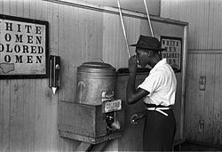
http://en.wikipedia.org/wiki/Jim_Crow_laws

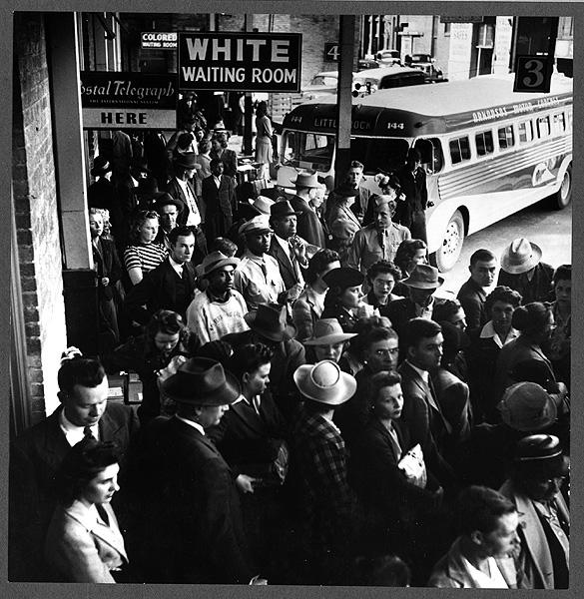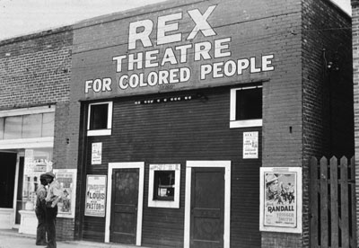
http://history.howstuffworks.com/american-history/civil-rights-movement1.htm
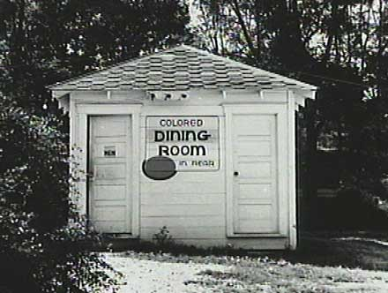
http://www.xtimeline.com/evt/view.aspx?id=26890

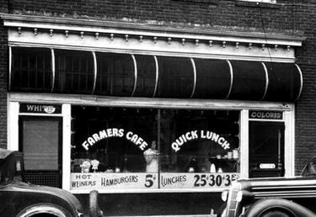
http://www.conservapedia.com/Jim_Crow

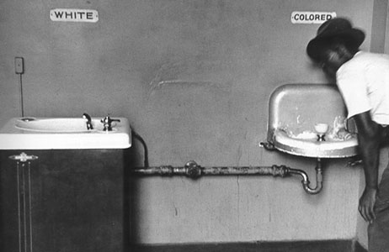
http://lmk11.wordpress.com/pictures/

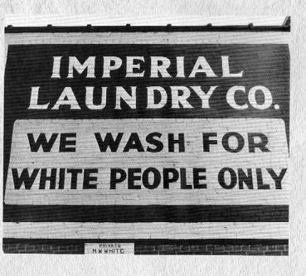
http://my.opera.com/Donut123/blog/jim-crow

